Assignment-6

Assignment 6: Given a sample log file, write a script using grep to extract all lines containing "ERROR". Use awk to print the date, time, and error message of each extracted line.

Shell script code with the name of extract_errors.sh:
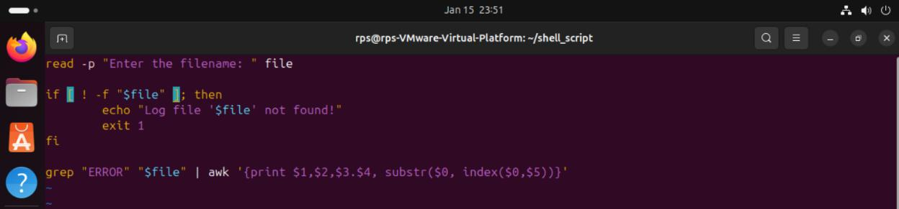

Commands to run extract_errors.sh and checking its function:
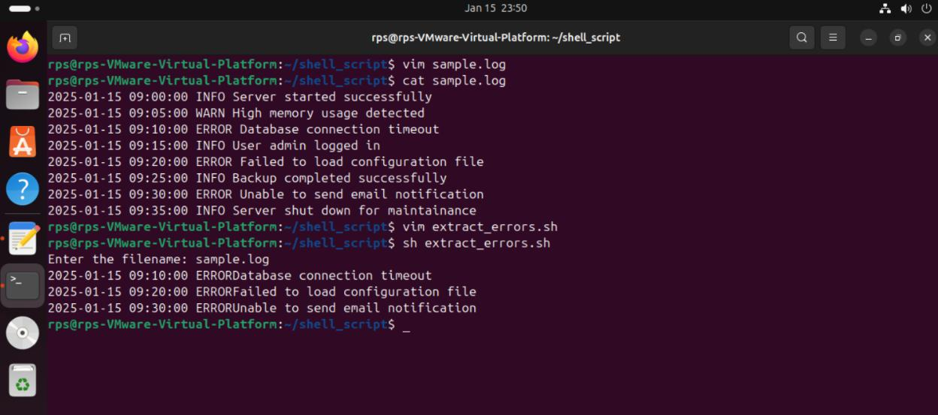

21958-Lokesh_Panem

